2025 MDI Photo Club Exhibit

Ready to be Hung Requirements

Ideal:
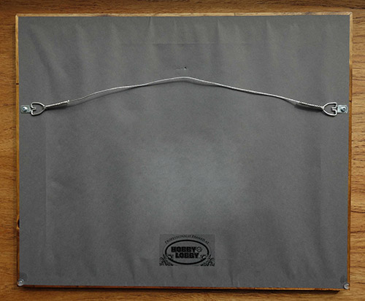
Attach wire anchor ¹/₄ to ¹/₃ down
from the top of the frame.

The wire when pulled taut
towards the top of the frame
should be no closer than two inches from the top of the frame.
This will hide the hanging hardware when hung in the Mellon Room.

Figure 1 Perfect

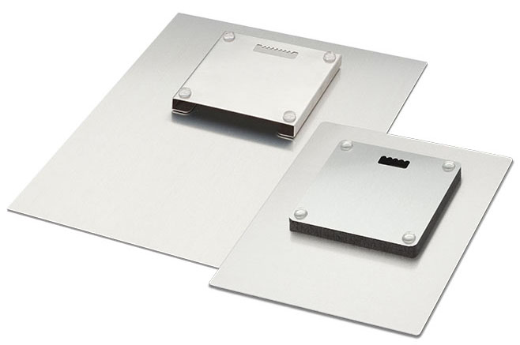
Figure 2 Also Good Metal Print with Float Mount

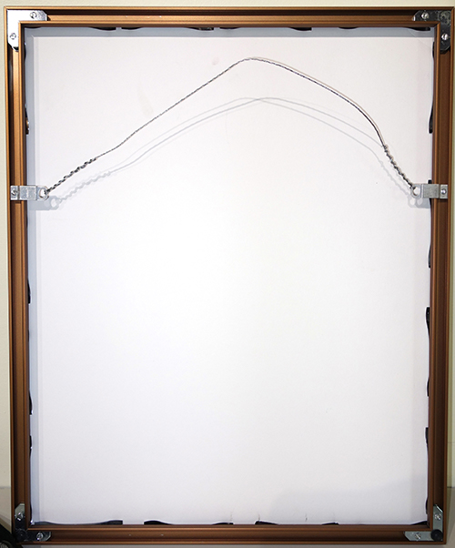
Figure 3 Wire too slack

Wire is too close to top of frame when pulled taught.

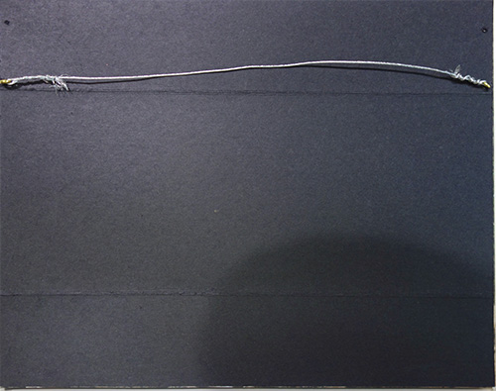
Figure 4 High Wire

Wire attachments are too close to top of frame and wire has insufficient slack.

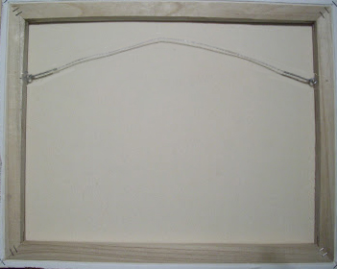

D-ring clips mounted on back face are also acceptable.
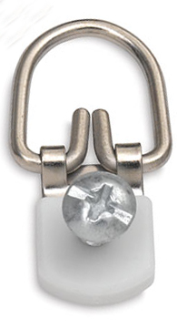

Figure 5 Canvas Print Methods
Sawtooth hangers are not acceptable.

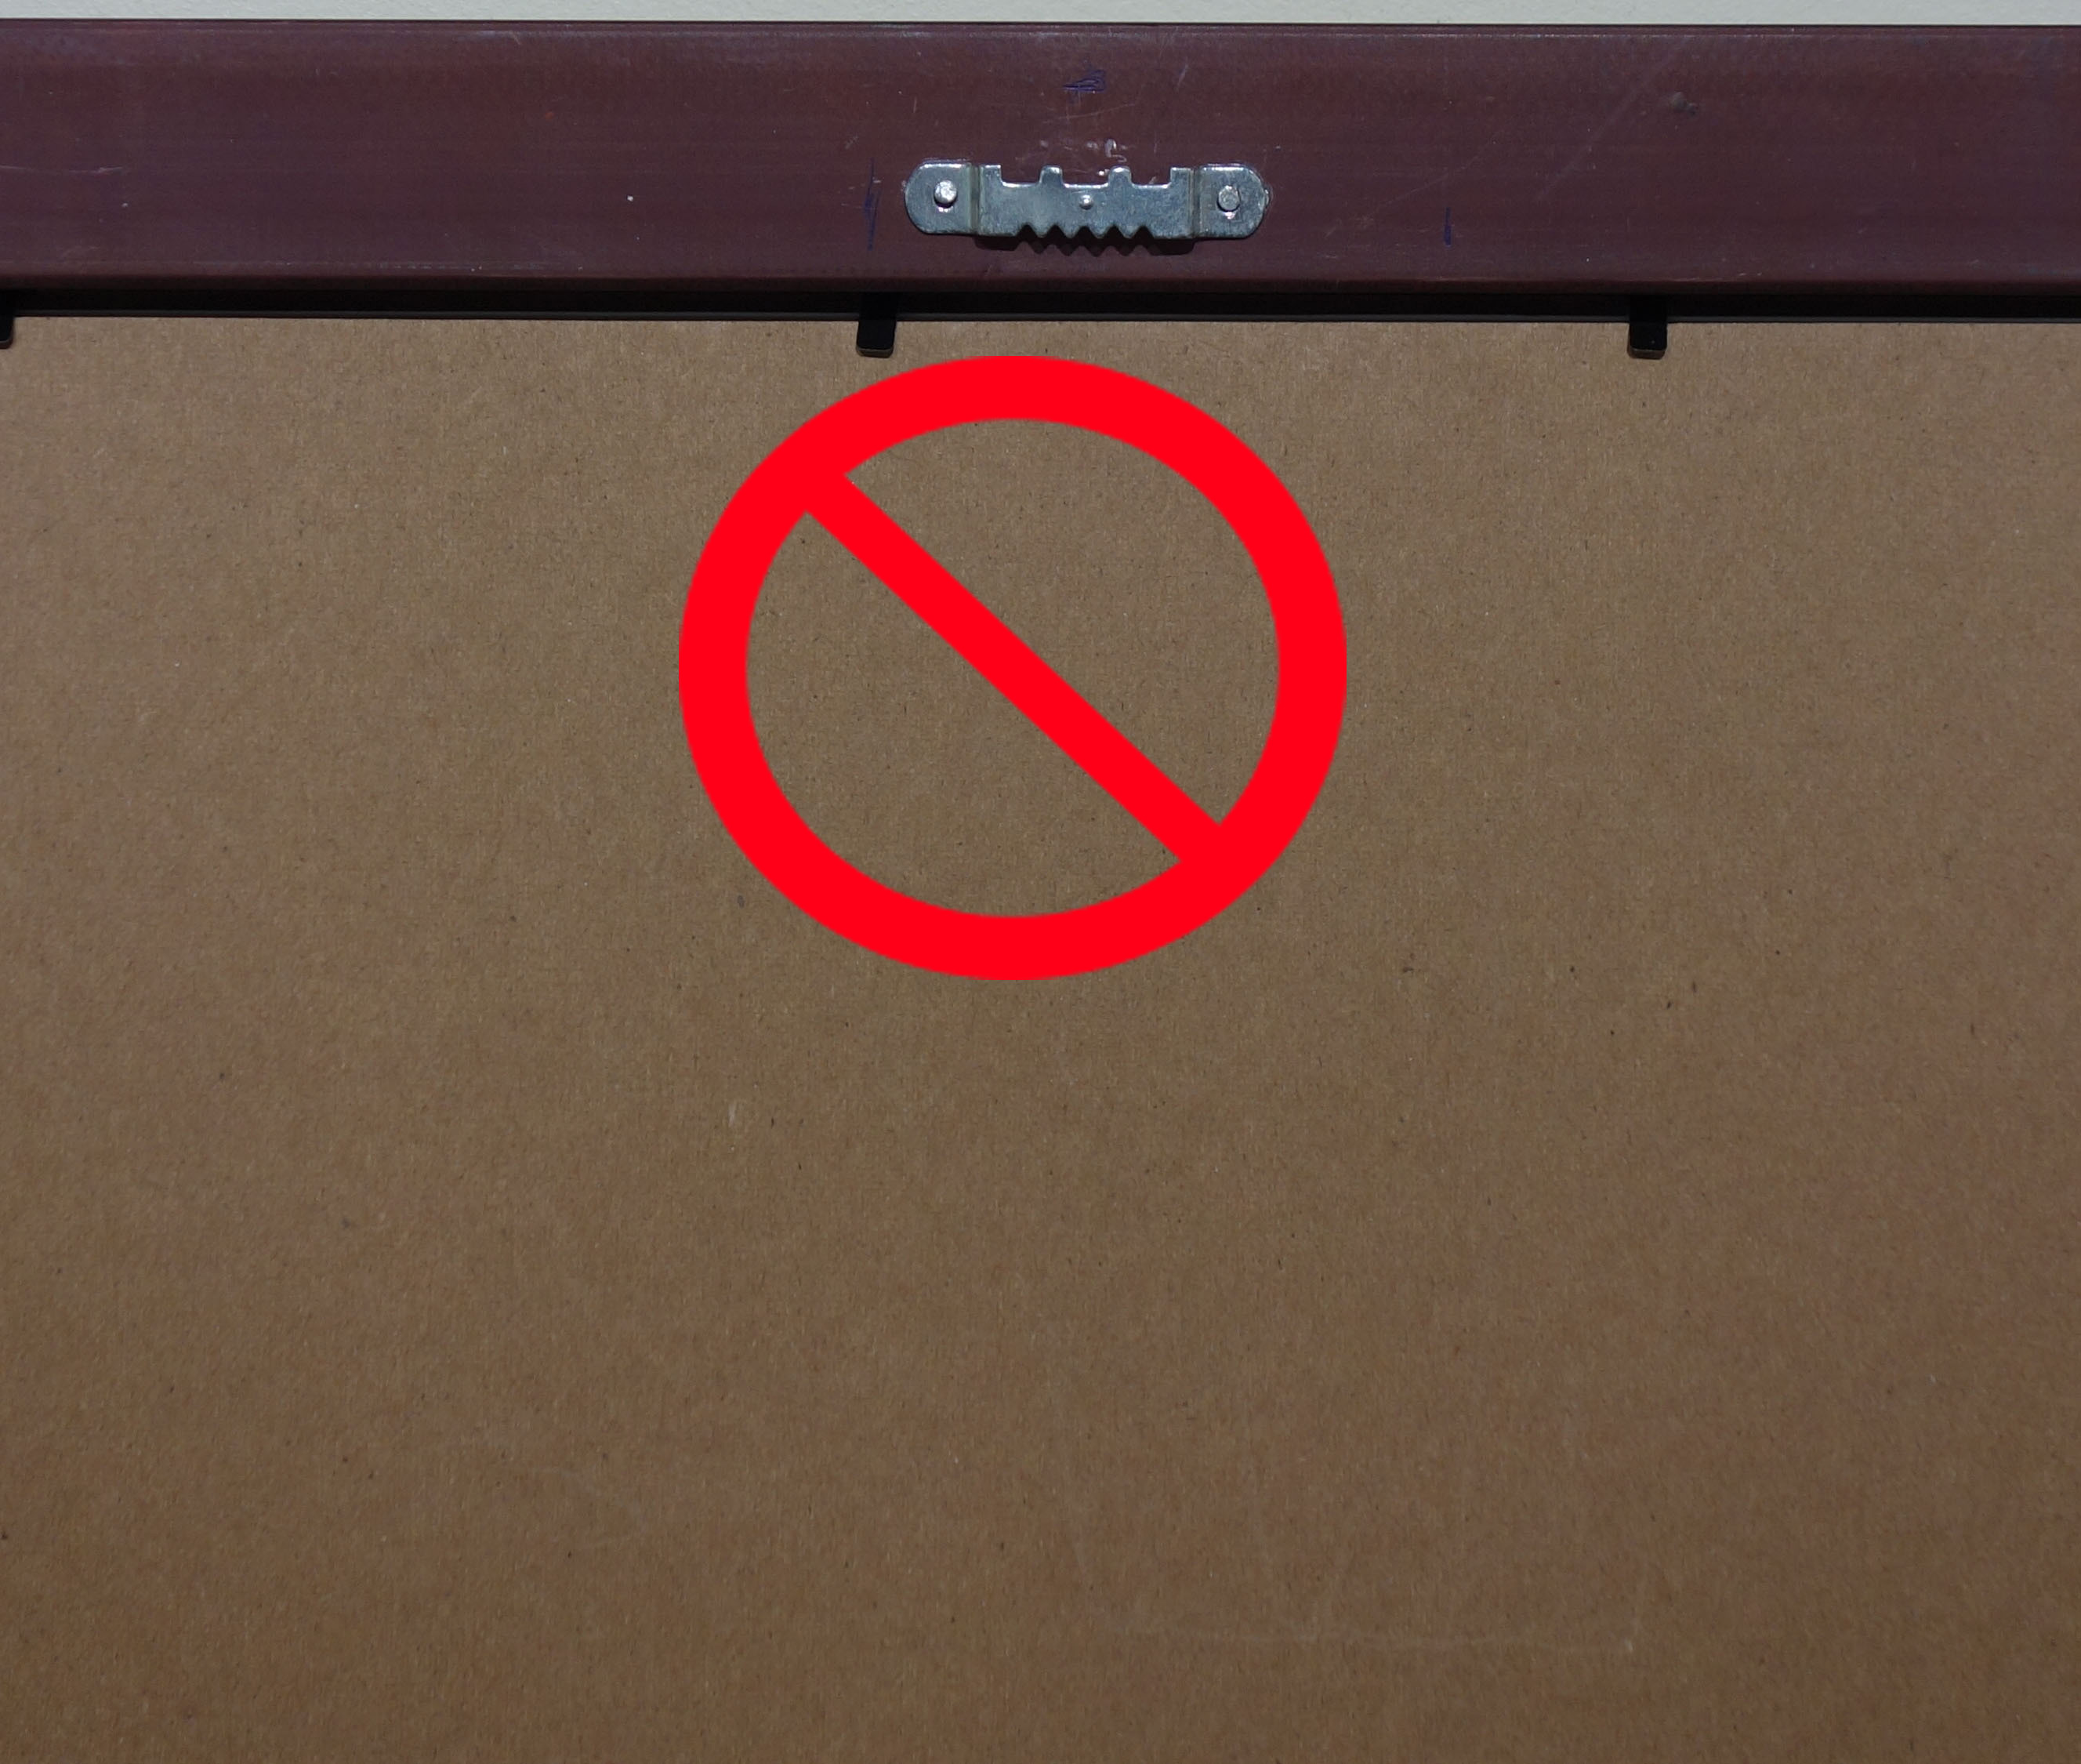
Figure 6 Sawtooth – NO

Questions about “ready to hang” should be directed to Caitlin Small at (401) 225-7407 or exhibit@mdiphotoclub.org.

